**Dashboard Images**

1. **Airport Analysis and Delays :**

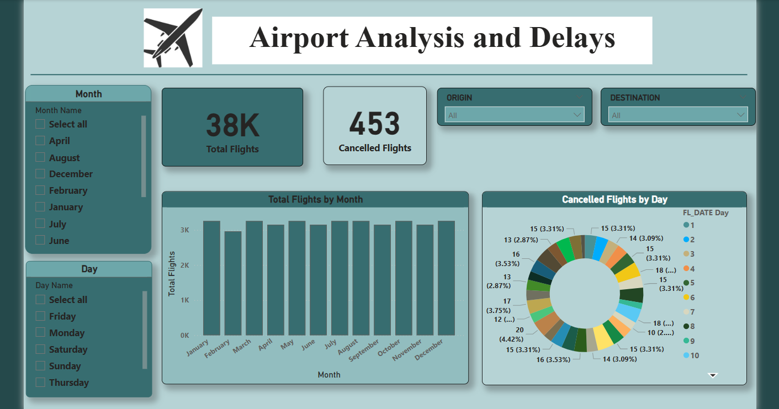

1. **Overview :**

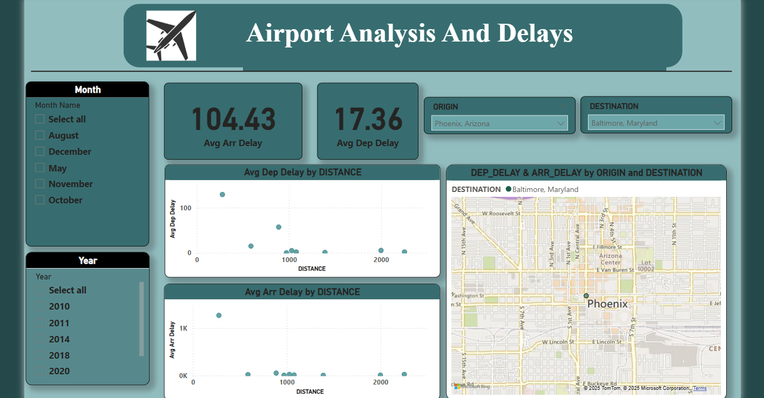

1. **Detailed flight Analysis :**

